Weekly Chore Chart
Put together by Sherna Pinnock, Villa School’s Curriculum Specialist.

This weekly chore table showcases a variety of chores that can be done at home. The tasks written in text are supported by pictures, one of the ways in which our students communicate. You can make your own weekly chore table by changing the text and pictures!

CHORES
Monday | Wash Dishes  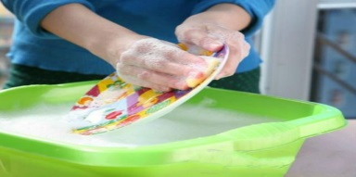
Tuesday | clean 4 doorknobs
Wednesday | Set the table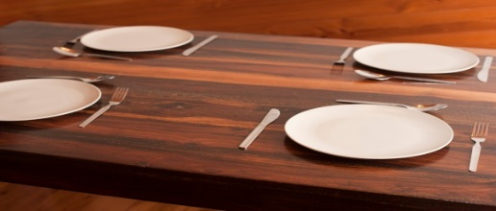
Thursday | Take out bathroom trash  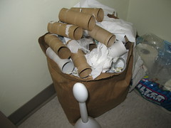
Friday | Clean counter/dust dresser  